Egyptian Chinese University
Faculty of Computers and Information Systems

THE KINGDOM ROADS
Minimum Spanning Tree — Project Documentation

Course | Theory of Algorithms
Project Title | The Kingdom Roads — MST Solver
Student 1 | Ali Nabil Abu Elenin — ID: 692400395
Student 2 | Bola Atef Aziz Mashraky Rizk — ID: 692400034
Supervisor | TA / Toqa Hamdy Serag
University | Egyptian Chinese University

Table of Contents
1. Problem Description............................................................3
2. Algorithms Used............................................................4
2.1 Kruskal's Algorithm............................................................4
2.2 Prim's Algorithm............................................................5
2.3 Comparison............................................................6
3. Complexity Analysis............................................................7
4. GUI Description............................................................8
5. Test Cases & Results............................................................9
6. Conclusion............................................................11

1. Problem Description
The Kingdom of Eldoria has several castles connected by roads. Due to an invasion, many roads have been destroyed, leaving only a few intact. The King has tasked us with determining the minimum number of roads needed to connect all castles so that messages can be sent across the kingdom without delay.

Problem Statement
Given a set of castles and roads connecting them (each road has a cost), find the minimum number of roads required to connect all castles — this is known as the Minimum Spanning Tree (MST) problem.

Key Concepts
- Graph: A set of castles (vertices) connected by roads (edges) with weights (costs).
- MST: A subset of edges that connects all vertices with no cycles and minimum total cost.
- For N castles, exactly N−1 roads are needed in the MST.

Test Cases
Test Case | Input Graph | Output & Explanation
Test Case 1 | {0: [(1,10),(2,6)], 1: [(3,5)], 2: [(3,15)], 3: []} | Output: 3  Roads: (0,1), (1,3), (2,3) | Total Cost: 21
Test Case 2 | {0: [(1,5)], 1: [(2,7)], 2: [(3,8)], 3: []} | Output: 3  Roads: (0,1), (1,2), (2,3) | Total Cost: 20
Test Case 3 | {0: [(1,1),(2,4)], 1: [(2,2),(3,3)], 2: [(3,1)], 3: []} | Output: 3  Roads: (0,1), (1,2), (2,3) | Total Cost: 4

2. Algorithms Used
Both algorithms are Greedy algorithms — they make the locally optimal choice at each step to achieve a globally optimal solution (the MST).
2.1 Kruskal's Algorithm
Kruskal's algorithm is edge-based. It processes all edges sorted by cost and greedily picks the cheapest edge that does not create a cycle.

How it works:
- Step 1: Collect all roads (edges) into a list.
- Step 2: Sort the list from cheapest to most expensive.
- Step 3: For each road (in order), add it to the MST only if it does NOT create a cycle.
- Step 4: Stop when all castles are connected (N−1 edges selected).

Cycle Detection — Union-Find:
Union-Find (Disjoint Set Union) is used to detect cycles efficiently:
- find(x) — returns the root/representative of castle x's group.
- unite(x,y) — merges the groups of castles x and y.
- If find(castle1) == find(castle2) → they are already connected → skip the road.

Example on Test Case 1:
Road | Cost | Check | Decision
1-3 | 5 | No cycle | Added ✓
0-2 | 6 | No cycle | Added ✓
0-1 | 10 | No cycle | Added ✓
2-3 | 15 | Cycle! | Skipped ✗

2.2 Prim's Algorithm
Prim's algorithm is vertex-based. It grows the MST one castle at a time, always extending to the nearest unvisited castle.

How it works:
- Step 1: Start from castle 0; mark it as visited.
- Step 2: Look at all roads connecting visited castles to unvisited ones.
- Step 3: Pick the cheapest road and add the new castle to the MST.
- Step 4: Repeat until all castles are visited.

Data Structures used:
- visited[] — tracks which castles have been added to the MST.
- minCost[] — stores the minimum road cost to reach each unvisited castle.
- parent[] — stores which castle each castle was reached from.

Example on Test Case 1:
Step | Visited | Available Roads | Edge Added
Start at 0 | {0} | Neighbours: 1(10), 2(6) | —
Visit 2 | {0,2} | Neighbours: 1(10), 3(15) | Road (0,2) cost 6
Visit 1 | {0,1,2} | Neighbours: 3(5) via 1 | Road (0,1) cost 10
Visit 3 | {0,1,2,3} | All visited | Road (1,3) cost 5

2.3 Comparison Between Algorithms
Property | Kruskal | Prim
Approach | Edge-based | Vertex-based
Starts from | Cheapest edge | Castle 0
Uses | Union-Find | Visited Array
Time Complexity | O(E log E) | O(V²)
Space Complexity | O(V + E) | O(V)
Best for | Sparse Graphs | Dense Graphs
Result | Same MST | Same MST

3. Complexity Analysis
Complexity analysis measures how the algorithm's performance scales as the input grows. We analyse both Time (how many steps) and Space (how much memory).

Kruskal — Time Complexity: O(E log E)
Operation | Cost | Note
Sort all edges | O(E log E) | Dominant step
Union-Find per edge | O(E · α(V)) | α ≈ constant (nearly O(1))
Total | O(E log E) | Largest term wins
Space Complexity: O(V + E) — stores parent array O(V) + edge list O(E)

Prim — Time Complexity: O(V²)
Operation | Cost | Note
Outer loop (all castles) | O(V) | Visits each castle once
Inner loop (find min cost) | O(V) | Scans all castles each time
Total | O(V²) | Nested loops
Space Complexity: O(V) — only stores visited[], minCost[], parent[] arrays

When to use which?
Sparse Graph (few roads, E ≈ V): Kruskal wins → O(V log V) vs O(V²)
Dense Graph (many roads, E ≈ V²): Prim wins → O(V²) vs O(V² log V)

4. GUI Description
The graphical interface was built using the SFML library (Simple and Fast Multimedia Library) in C++. SFML provides tools for drawing shapes, text, handling mouse events, and animations.

SFML Components Used
Component | Purpose
sf::RenderWindow | Creates the application window (1000×800 pixels)
sf::CircleShape | Draws castle hexagons, glow effects, and animated stars
sf::RectangleShape | Draws buttons, result boxes, and decorative panels
sf::Text / sf::Font | Renders all text labels, titles, and results
sf::Vertex / Lines | Draws roads (edges) between castles
sf::Mouse | Detects mouse position for hover effects
sf::Event | Handles click events and window close

Screens Overview
• Menu Screen: User selects algorithm (Kruskal/Prim) then selects a Test Case. Animated stars move in the background. University info shown at bottom.
• Graph Screen: Displays the castle graph. Gray lines = all roads. Green thick lines = MST roads selected. Castle numbers shown inside hexagons.
• Result Box: Shows selected MST roads, total cost, and roads count at the bottom.
• Legend: Color guide: green = MST road, gray = all roads.

5. Test Cases & Results
The following screenshots show the GUI running each test case with both algorithms.

Menu Screen
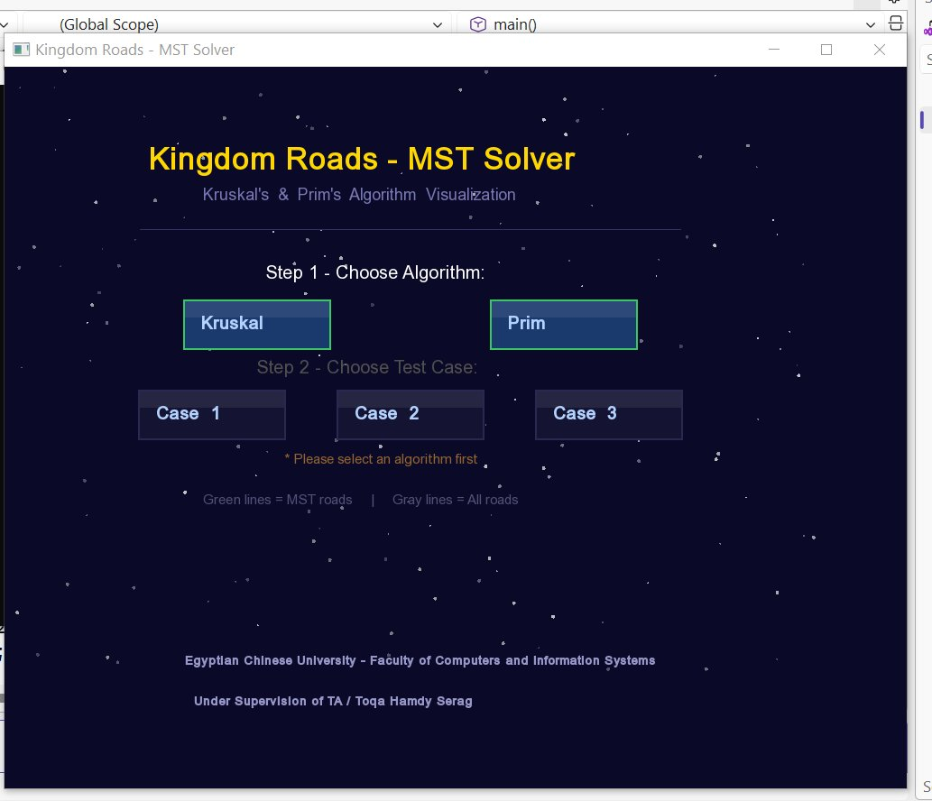

Test Case 2 — Kruskal's MST
Input: {0:[(1,5)], 1:[(2,7)], 2:[(3,8)], 3:[]}
Selected Roads: (0,1), (1,2), (2,3) | Total Cost: 20 | Roads Count: 3
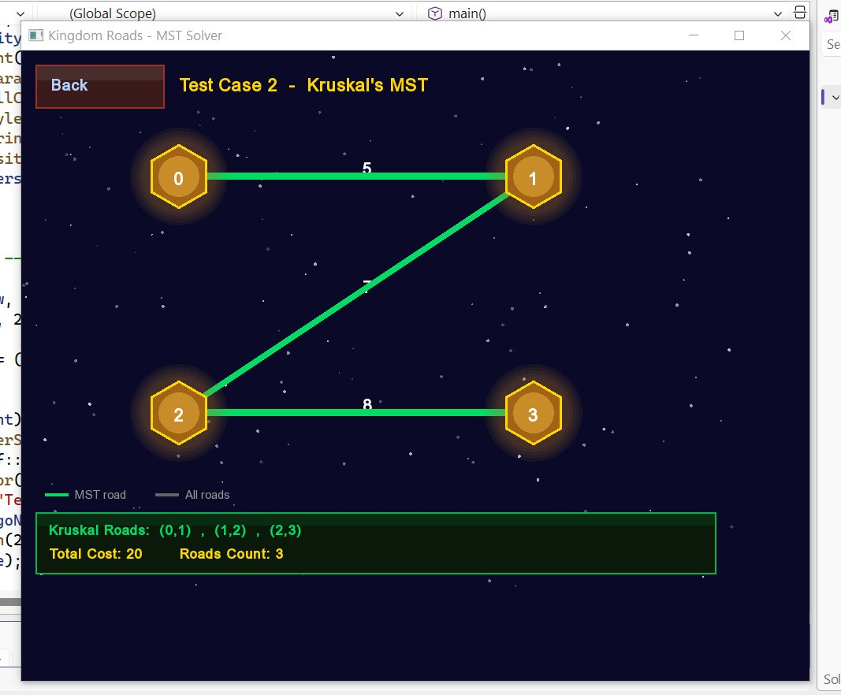

Test Case 3 — Prim's MST
Input: {0:[(1,1),(2,4)], 1:[(2,2),(3,3)], 2:[(3,1)], 3:[]}
Selected Roads: (0,1), (1,2), (2,3) | Total Cost: 4 | Roads Count: 3
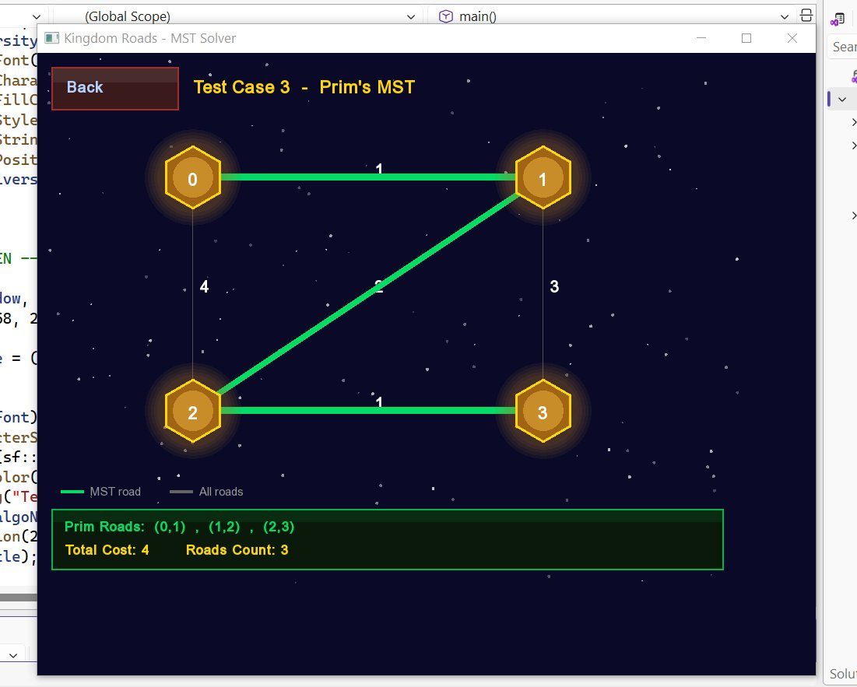

Results Summary
Test Case | Algorithm | Roads Selected | Total Cost | Count
Test Case 1 | Kruskal | (1,3),(0,2),(0,1) | 21 | 3
Test Case 1 | Prim | (0,2),(0,1),(1,3) | 21 | 3
Test Case 2 | Kruskal | (0,1),(1,2),(2,3) | 20 | 3
Test Case 2 | Prim | (0,1),(1,2),(2,3) | 20 | 3
Test Case 3 | Kruskal | (0,1),(2,3),(1,2) | 4 | 3
Test Case 3 | Prim | (0,1),(2,3),(1,2) | 4 | 3

6. Conclusion
This project successfully implemented and visualised the Minimum Spanning Tree problem using two Greedy algorithms — Kruskal's and Prim's — in C++ with an SFML graphical interface.

Key Findings
- Both algorithms produce the same MST result across all three test cases.
- Kruskal's algorithm is more efficient for sparse graphs (O(E log E) time).
- Prim's algorithm uses less memory (O(V) space) and suits dense graphs better.
- The GUI allows interactive selection of algorithm and test case for clear comparison.
- Union-Find is a powerful tool for cycle detection in Kruskal's algorithm.

Technologies Used
Language: C++
GUI Library: SFML 2.6.1
IDE: Microsoft Visual Studio 2022
Algorithm 1: Kruskal's (Greedy, Edge-based, O(E log E))
Algorithm 2: Prim's (Greedy, Vertex-based, O(V²))

Egyptian Chinese University • Faculty of Computers and Information Systems • Theory of Algorithms

